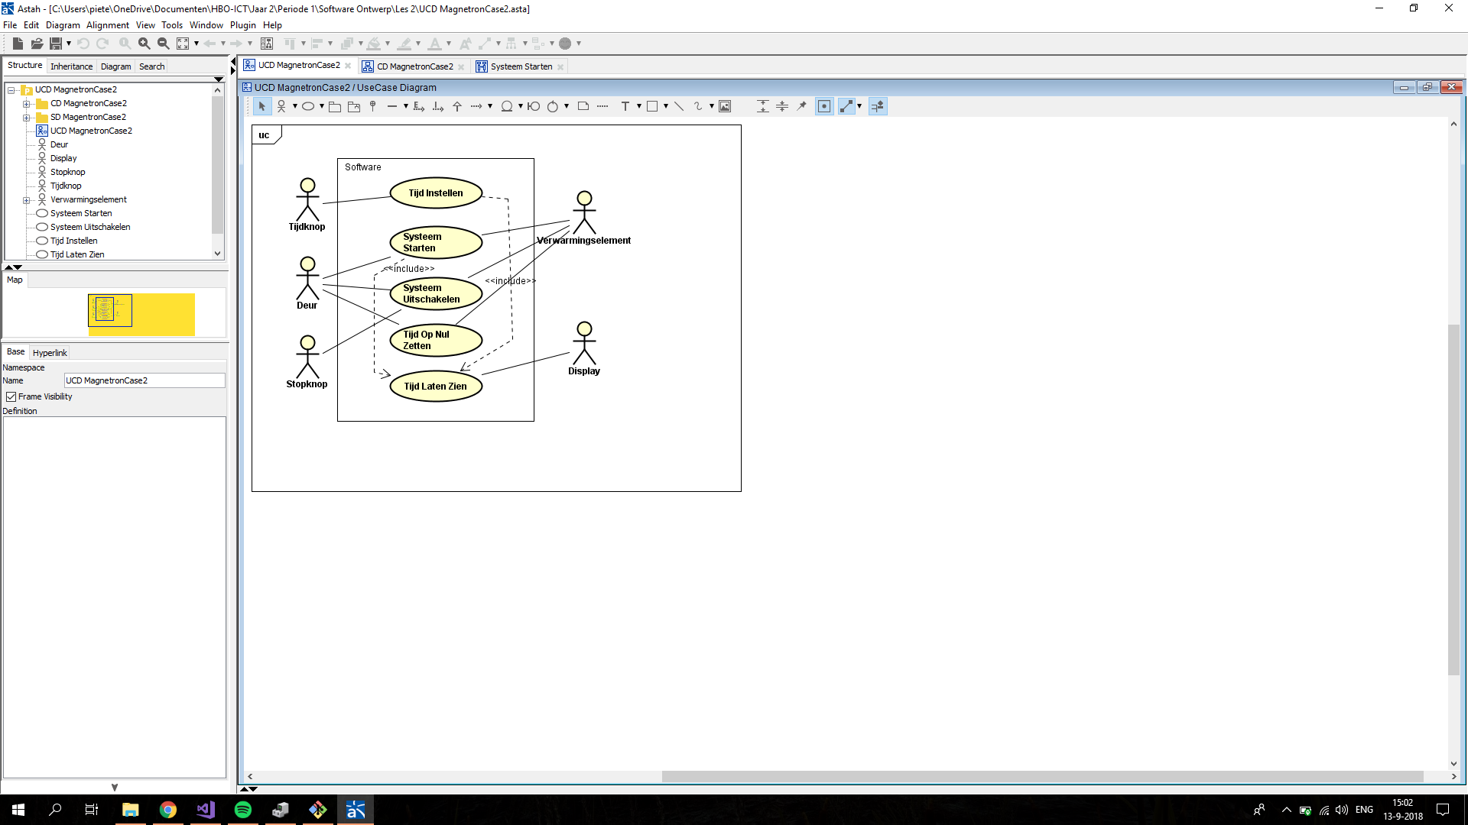

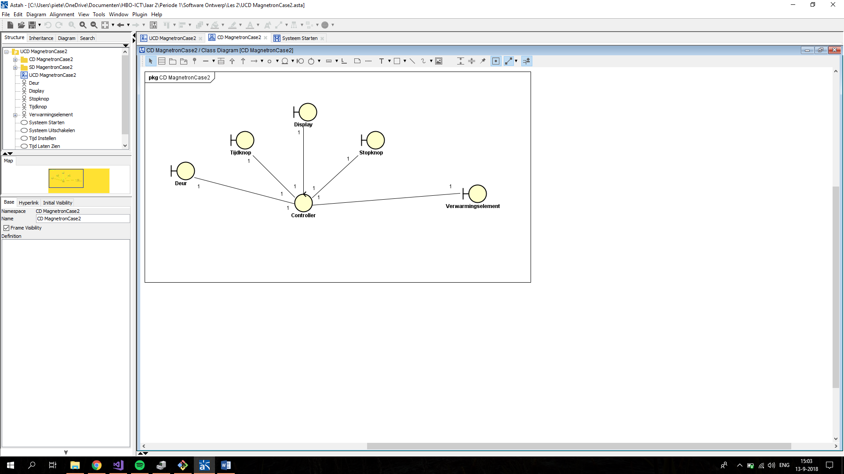

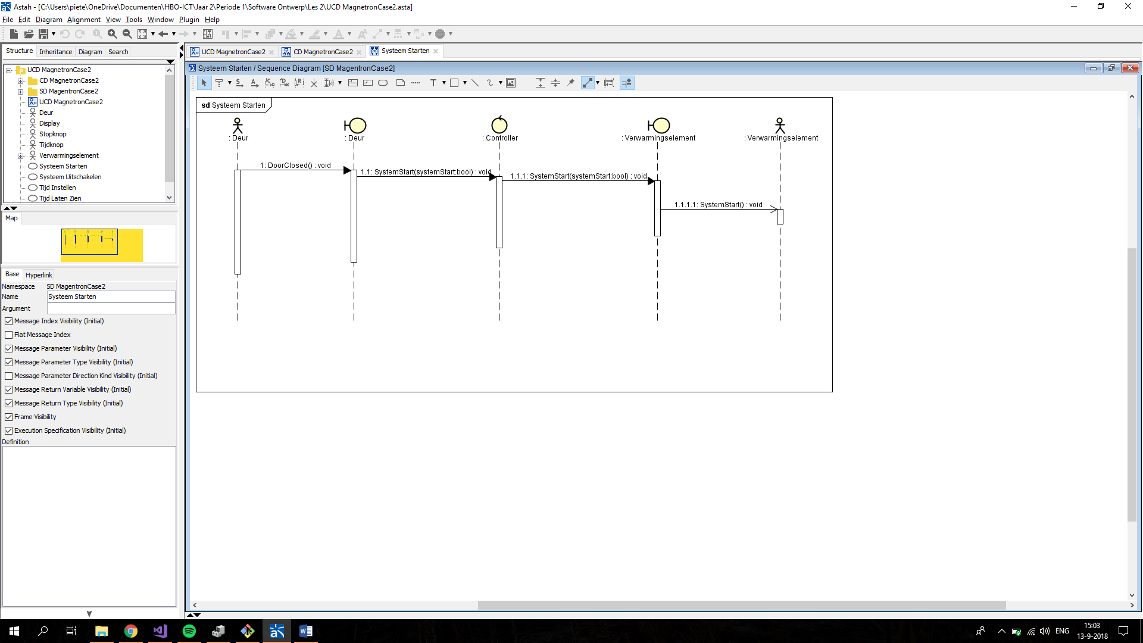

namespace CD MagnetronCase2

{

public class Verwarmingselement

{

public void SystemStart(bool systemStart)

{

}

}

}

namespace CD MagnetronCase2

{

public class Tijdknop

{

}

}

namespace CD MagnetronCase2

{

public class Stopknop

{

}

}

namespace CD MagnetronCase2

{

public class Display

{

}

}

namespace CD MagnetronCase2

{

public class Deur

{

public void DoorClosed()

{

}

}

}

namespace CD MagnetronCase2

{

public class Controller

{

public bool systemStart;

public void SystemStart(bool systemStart)

{

}

}

}